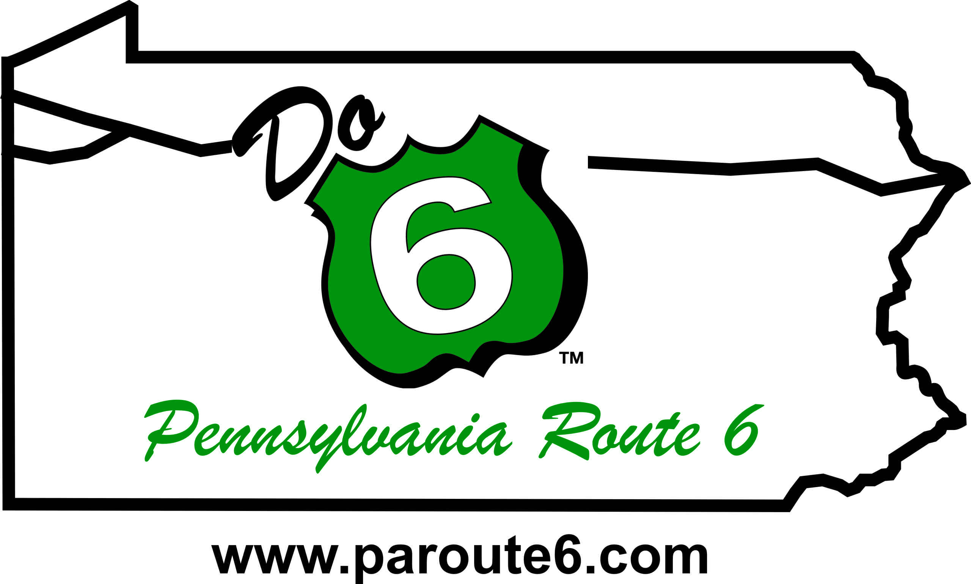
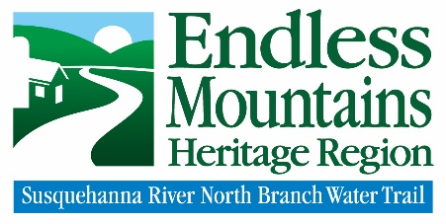

For Immediate Release

June 30, 2020

The PA Route 6 Alliance and Endless Mountains Heritage Region (EMHR) are pleased to announce the award of Façade Program grant funding to 29 businesses within the PA Route 6 Heritage Corridor of Bradford and Wyoming counties. The awards will facilitate improvements that enhance the exterior appearance of each business property, collectively resulting in a profound impact on the region’s communities.

“After very well-attended public meetings in February, our grant review committee received 57 applications between the two counties,” said executive director, Candace Hillyard. “We were very pleased to have received such a great response, especially considering the COVID-19 pandemic.”

The PA Route 6 Façade Program in the Endless Mountains provides commercial property owners, nonprofits, and business owners (with property owner approval) funding to implement façade improvements, such as new signage, awning installation, safety upgrades, and exterior paint.

“Even with the challenges of the pandemic, these business owners seem eager to start their projects and improve their towns,” explained program coordinator, Vanessa Billings-Seiler. “The high-quality applications made our job of selecting award recipients extremely difficult, but we are now excited to see these changes take shape over the coming months.”

With a total program cost of $292,180.62, the PA Route 6 Façade Program in the Endless Mountains is made possible by a $103,000 Keystone Communities grant from the PA Dept. of Community and Economic Development (DCED), project support funding from the PA Dept. of Conservation & Natural Resources (DCNR), and matching funds from award recipients totaling $187,696.12.

Find a complete list of award recipients and more information on the program at https://paroute6.com/facade or by contacting the PA Route 6 Alliance at info@paroute6.com or 814-435-7706.

The PA Route 6 Alliance, a 501(c3) corporation, was established in 2003 to manage the PA Route 6 Heritage Corridor and to implement branding and marketing plans, community development programs and other planning efforts along the corridor. The Alliance includes representatives from all 11 counties, 9 convention and visitor bureaus, 4 heritage areas, local development districts, local business owners, Chambers of Commerce, and other interested parties along the corridor.
--End--

